SIMATS ENGINEERING
ASSESSMENT TOOL 2: Industry Problem Solving Task

COURSE NAME: Cloud Computing and
Big Data Analytics
COURSE CODE: CSA1507

COURSE OUTCOME COVERED
CO4: Analyze big data characteristics and challenges across domains including security and application aspects.
(BL4)

Dave's Taxonomy: Articulation (Level 4) Question Count: 5
Total Marks: 40

Duration :60 Minutes
Code of Conduct
I DIVYA.K (192511316)_ (Name / Reg No) certify that this submission is my original work and that I have adhered to the guidelines specified for this assessment.
I understand that any violation of academic integrity rules will result in disciplinary action. Signature of the student: DIVYA

Assessment Tasks
Industry Problem Solving Task
- Retail Data Optimization Problem - A retail chain operates both physical stores and an online platform. It generates large volumes of sales, inventory, and customer behavior data. The company wants real-time inventory tracking and demand forecasting. It also aims to deliver personalized marketing recommendations to customers. Design a big data architecture to support these requirements. Explain the tools, technologies, and analytics models you would use.

- Social Media Fraud Detection Problem - A social media platform processes billions of user interactions daily. These include posts, comments, likes, and shares. The platform wants to detect fake accounts and misinformation quickly. Real-time or near real-time processing is required. Design a scalable big data solution for this use case. Explain the role of machine learning and stream processing frameworks.

- Government Data Platform Problem A government agency is building a national data platform. It combines census, economic, and geospatial datasets. Different departments need access to shared and integrated data. The system must ensure interoperability across multiple agencies. Strict privacy and security requirements must be followed. Propose a governance and data management strategy.

- Banking Fraud Detection Problem
A bank processes millions of financial transactions every minute. It needs to detect fraudulent activities in real time. The system must analyze historical and streaming transaction data.
Low latency and high accuracy are critical requirements. Design a big data pipeline for fraud detection. Explain the technologies and algorithms you would implement.

- Agriculture Smart Farming Problem
A smart farming system collects soil, weather, and crop data. Sensors and drones provide real-time field information. Farmers want insights to improve yield and resource usage. Data is generated from multiple distributed sources. Design a big data solution for precision agriculture. Explain how analytics can support decision-making.

Industry Problem Solving Rubric

Criteria | Weightage | Level 4 - Exemplary | Level 3 - Proficient | Level 2 - Developing | Level 1 - Beginning
Understanding of Industry Context | 20% | Demonstrates strong understanding of  real-world problem context | Good understanding | Basic understanding | Weak understanding
Application of Big Data Concepts | 25% | Applies highly relevant big data ideas and tools | Mostly appropriate application | Partial application | Weak application
Solution Design | 25% | Solution is practical, scalable,  and well-reasoned | Reasonable solution | Basic solution with gaps | Unclear solution
Security / Risk Awareness | 15% | Strong awareness  of security and operational risks | Reasonable awareness | Limited awareness | Poor awareness
Clarity and Professionalism | 15% | Well-structured and professional response | Generally clear | Moderately clear | Poorly presented

Total Marks Awarded:

ANSWER:

RETAIL DATA OPTIMIZATION PROBLEM

Proposed Big Data Architecture:

A retail company needs to process data from physical stores, online shopping, inventory systems, customer interactions, and sales transactions. A suitable architecture can combine batch processing with real-time analytics.
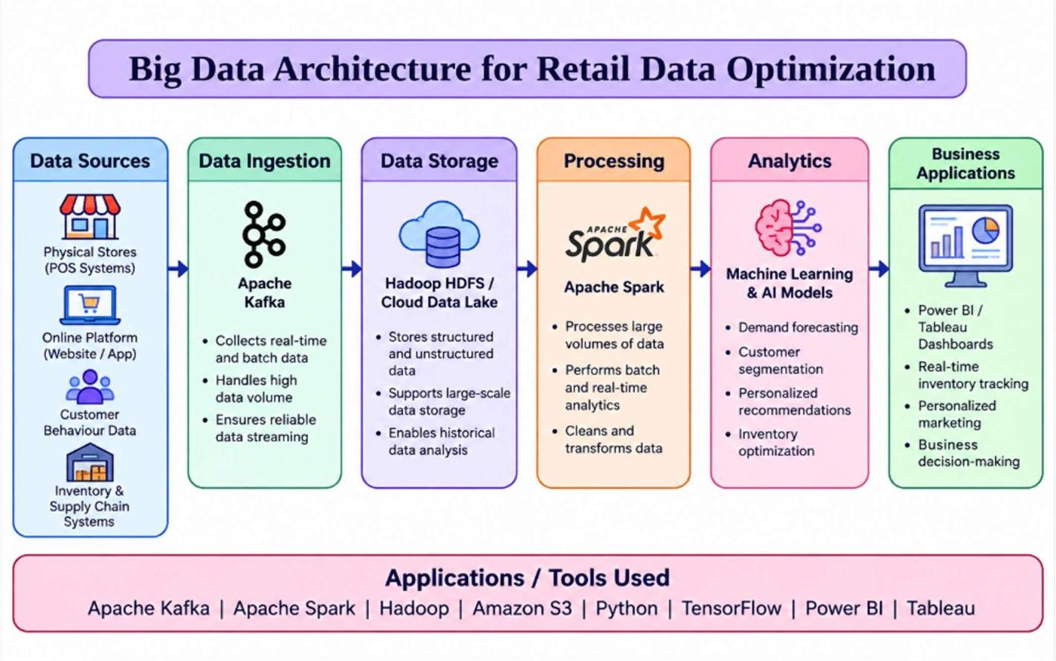

Data Collection:

Data can be collected from:

    - Point-of-sale (POS) systems

    - E-commerce websites and mobile applications

    - Inventory and warehouse systems

    - Customer browsing and purchase history

    - Social media and customer feedback

Apache Kafka can be used to collect and stream large volumes of real-time sales and inventory events.

Data Storage:

A distributed storage system such as Hadoop HDFS or a cloud data lake can store structured and unstructured data. Historical sales, customer information, product details, and inventory records can be maintained for analysis.

Data Processing:

Apache Spark can process both historical and real-time data. Spark Streaming can continuously process sales and inventory updates to identify low-stock products.

Analytics and Machine Learning:

Demand forecasting can use models such as:

    - Linear Regression

    - Random Forest

    - XGBoost

    - LSTM for time-series forecasting

Customer recommendation can use collaborative filtering and content-based recommendation.

Business Benefits:

The architecture provides:

    - Real-time inventory monitoring

    - Accurate demand forecasting

    - Personalized product recommendations

    - Reduced overstock and stockouts

    - Better customer experience

Conclusion:

A combination of Kafka + Data Lake/HDFS + Spark + Machine Learning provides a scalable architecture for retail data optimization.

SOCIAL MEDIA FRAUD DETECTION PROBLEM:

Proposed Big Data Solution:

A social media platform generates billions of posts, comments, likes, shares, and user activities. Since fraudulent accounts and misinformation must be detected quickly, the system should use stream processing and machine learning.
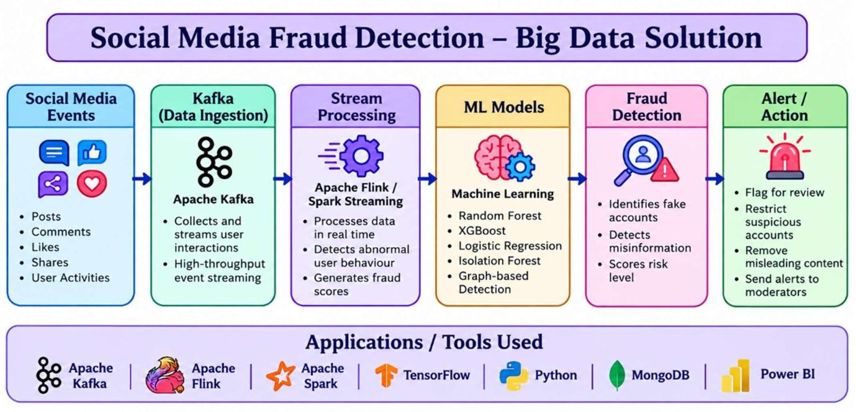

Data Ingestion:

User activities such as login attempts, posts, comments, likes, shares, and follower changes can be continuously collected using Apache Kafka.
Kafka provides high-throughput and fault-tolerant event streaming.

Stream Processing:

Apache Flink or Spark Streaming can process events in real time. For example, if an account suddenly:
    - Creates hundreds of posts

    - Sends thousands of friend requests

    - Repeats identical comments

    - Shares suspicious links rapidly

the streaming system can immediately generate a fraud score.

Machine Learning:

Machine learning can identify abnormal user behaviour. Useful algorithms include:
    - Random Forest

    - XGBoost

    - Logistic Regression

    - Isolation Forest for anomaly detection

    - Graph-based algorithms for identifying coordinated fake accounts

Misinformation Detection:

Natural Language Processing (NLP) models can analyze text, URLs, and content patterns to classify potentially misleading information.

Action Layer:

High-risk accounts can be:

    - Flagged for review

    - Temporarily restricted

    - Sent for additional verification

    - Given lower content visibility

Conclusion:

Kafka + Flink/Spark Streaming + Machine Learning enables scalable and near-real-time detection of fake accounts and misinformation.

GOVERNMENT DATA PLATFORM PROBLEM:

Industry Problem Solving Approach:

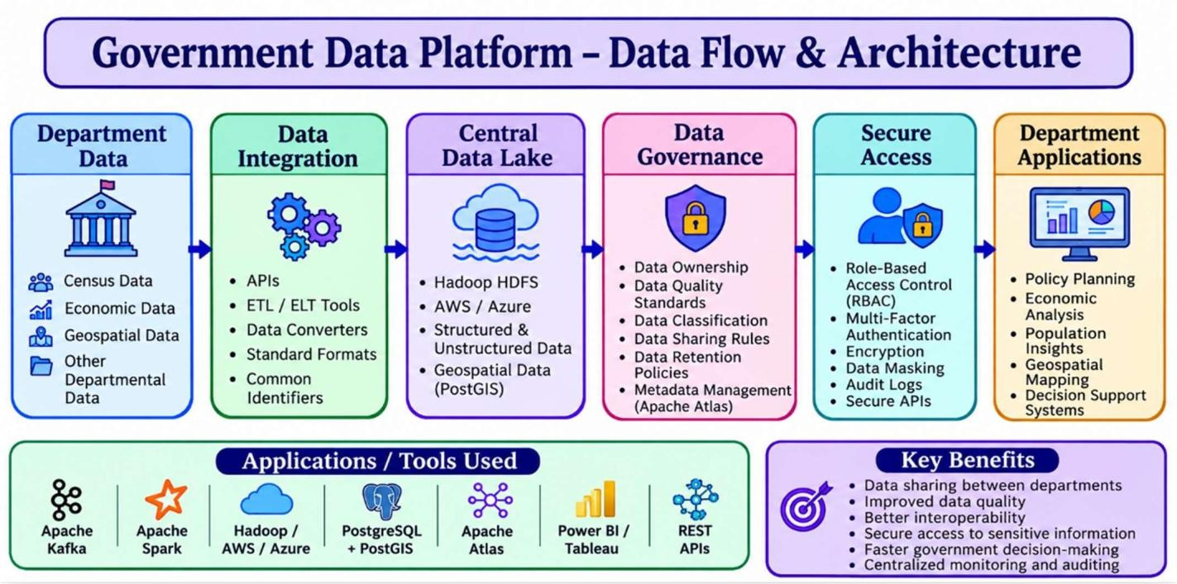
A government agency needs to combine census, economic, and geospatial data from different departments. The main challenge is to make this data shared, interoperable, secure, and reliable.

Data Collection and Integration:

    - Data can be collected from census systems, economic databases, GIS systems, and departmental applications.
    - Tools such as Apache Kafka, APIs, and ETL/ELT tools can integrate data from different sources.

Central Data Storage:

    - A government data lake using Hadoop HDFS or cloud storage such as AWS/Azure can store large amounts of structured and unstructured data.
    - Geospatial data can be managed using PostgreSQL with PostGIS.

Data Governance:

A common governance framework should define:

    - Data ownership

    - Data quality standards

    - Data classification

    - Data sharing rules

    - Data retention policies

    - Data access permissions

Apache Atlas can be used for metadata management and data lineage.

Interoperability:

Different government departments may use different formats and systems. Therefore, standard APIs, common schemas, metadata standards, and unique identifiers should be used.
This allows departments to exchange and understand data consistently.

Privacy and Security:

Since government data may contain sensitive citizen information, the platform should implement:
    - Encryption

    - Role-Based Access Control (RBAC)

    - Multi-factor authentication

    - Data masking/anonymization

    - Audit logs

    - Secure APIs

Applications / Tools Used

Requirement | Application / Technology
Data streaming | Apache Kafka
Data storage | Hadoop / AWS / Azure
Database | PostgreSQL + PostGIS
Data governance | Apache Atlas
Data processing | Apache Spark
Data visualization | Power BI / Tableau

Practical Example:

Suppose the Census Department provides population data and the Economic Department provides income data. The platform integrates both datasets using common identifiers. Authorized departments can then analyze population and economic conditions together, while sensitive citizen information remains protected through access control and anonymization.

Benefits:

  - Data sharing between departments

  - Improved data quality

  - Better interoperability

  - Secure access to sensitive information

  - Reduced duplication of data

  - Faster government decision-making

  - Centralized monitoring and auditing

Conclusion:

A combination of Data Lake + APIs + Apache Kafka + Spark + PostgreSQL/PostGIS + Apache Atlas + strong security controls can create a scalable and interoperable national government data platform while maintaining privacy and security.

BANKING FRAUD DETECTION PROBLEM:

Proposed Big Data Pipeline:

Banks process millions of transactions continuously. Fraud detection therefore requires a system capable of analyzing real-time transaction streams along with historical customer data.
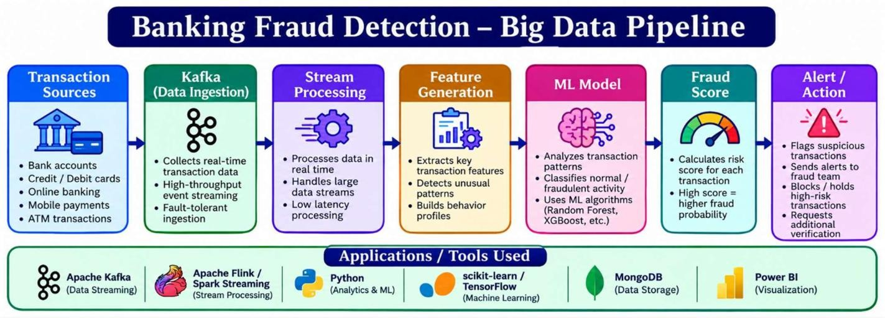

Data Collection:

Transaction data can include:

    - Account number

    - Transaction amount

    - Location

    - Time

    - Merchant

    - Device information

    - Previous transaction behaviour

Apache Kafka can collect transactions as real-time event streams.

Data Processing:

Apache Flink or Spark Streaming can process transactions with low latency. The system can calculate features such as:
    - Number of transactions in a short period

    - Average transaction amount

    - Unusual geographical location

    - New device usage

    - Sudden increase in transaction value

Machine Learning Algorithms:

The system can use:

    - Random Forest for classification

    - XGBoost for high-accuracy fraud prediction

    - Logistic Regression as a baseline model

    - Isolation Forest for anomaly detection

    - Neural networks for complex transaction patterns

Historical Analysis:

Historical transactions can be stored in a data lake/data warehouse. These records help train and continuously improve machine learning models.

Real-Time Decision:

Each transaction receives a fraud probability score. Based on predefined thresholds, the transaction can be:
    - Approved

    - Sent for additional verification

    - Temporarily blocked

    - Reported to the fraud investigation team

Conclusion:

Kafka + Flink/Spark + Machine Learning + Historical Data Storage provides a low-latency and scalable architecture for real-time banking fraud detection.

AGRICULTURE SMART FARMING PROBLEM:

Proposed Big Data Solution:

Precision agriculture generates data from soil sensors, weather stations, drones, satellites, GPS devices, and farm equipment. Big data technologies can combine these sources to help farmers make better decisions.
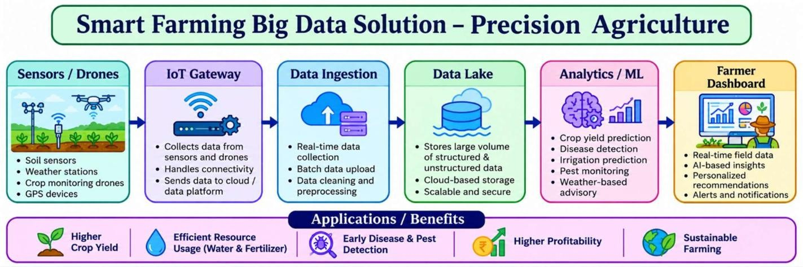

Data Collection:

Sensors can continuously collect:

    - Soil moisture

    - Soil temperature

    - pH level

    - Humidity

    - Rainfall

    - Crop health

    - Weather conditions

Drones and satellites can provide images for monitoring crop growth and detecting damaged areas.

Data Storage:

A cloud-based data lake can store sensor readings, drone images, weather information, and historical crop data.

Data Processing:

Apache Spark can process large volumes of agricultural data. Real-time processing can identify changes in soil moisture or weather conditions.

Analytics and Machine Learning:

Machine learning can be used for:

    - Crop yield prediction

    - Disease detection

    - Irrigation prediction

    - Fertilizer recommendation

    - Pest detection

    - Weather-based decision making

For example, a prediction model can analyze soil moisture, rainfall, temperature, and previous crop yield to estimate future production.

Decision Support:

A farmer dashboard can provide recommendations such as:

    - When to irrigate

    - Where fertilizer is required

    - Which areas require pest treatment

    - Expected crop yield

    - Early warnings about crop diseases

Conclusion:

Combining IoT sensors, drones, cloud storage, Spark, and machine learning enables precision agriculture, improves crop yield, reduces water and fertilizer usage, and supports data-driven farming decisions.

